**The problem now with the military synergy plan**

There has been a massive **restructuring of the military command structure in India** in recent times.

* **The post of Chief of Defence Staff (CDS)** has been created backed by the formation of the **Department of Military Affairs.**
* There is the **decision in principle to set up theatre commands**, centred on the theme of **tri-service integration.** A three-year timeline for rolling out theatre commands has been indicated by the CDS.

Kargil War of 1999:

* After the [Kargil War](https://byjus.com/free-ias-prep/this-day-in-history-jul26/), a decision was taken to overhaul the higher defence organization as **several weaknesses were detected, especially in the conduct of joint operations by the three services.** The imperative to create a Chief of Defence Staff (CDS) assumed great importance after the war.
* There was a comprehensive review of the entire command structure after the Kargil War.
* **The Kargil Review Committee (KRC)** was set up by the Government of India to examine the sequence of events and make recommendations for the future.
* A nuclear dimension had also come into the equation, following the 1998 nuclear tests, the ‘no first use’ doctrine, and the need for a second strike capability through a nuclear triad.
* But unfortunately, given the fact that both the military and civilian organizations are extremely reluctant to change, no significant changes were observed.
* **The Naresh Chandra task force (2011) reviewed the recommendations of the Kargil Review Committee**, assessed the implementation and accordingly suggested new changes needed relating to national security.
  + According to the task force, many of the main recommendations of the Kargil Review Committee have not been implemented.
  + The task force **deliberated on the theatre command concept but had recommended the formation of regional commands**

**Details:**

* The aim of the proposed integrated theatre commands is to bring about jointness and synergy in operations among the different military forces which would **increase the effectiveness of the forces** even while **reducing the cost of their operations** through the elimination of duplication and wasteful practices or processes.

Theatre command structure:

* Theatre commands framework is something which is desirable for India, given its present and future interests.
* The plan is to create theatre commands: Dedicated tri-service commands that are to be deployed along the northern border with China, the western border with Pakistan, an air defence command, and in the maritime domain, a peninsular command.
* Instead of having separate commands for every service, the CDS is working on having **a joint or theatre command** that can carry out all war-fighting formations under a single commander.
* In the absence of theatre commands, there would be the duplication of functions and roles.

Security challenges in the neighbourhood:

* The Doklam crisis with China and the Balakot airstrikes in Pakistan can be considered critical trigger points for the current focus on military reforms in India.
* The recent reforms will sharpen the combat edge of the Indian forces through streamlined tri-service operations.

Financial sense:

* The recent decisions may also be **financially driven.**
* The Navy and Air Force have repeatedly been requesting for more ships and fighter jets. Given the **limited resource base of India for military expenditure** and also the **changing nature of warfare,** there is the need to pool and share costly assets, bringing down operating costs.

The negative experience of tri-service command structure:

* **The Andaman and Nicobar Command is the first tri-service command, set up in 2001** to focus on India’s interests in south-east Asia and the Strait of Malacca. India has had a very patchy experience with respect to the tri-service command.
  + The joint command was not allowed to succeed because the three services did not want to share their assets, and did not post their best officers on it.
  + The Andaman and Nicobar Command did not take off because **no service allocated resources**. Theatre commands work best when you have dedicated assets.
* The negative experience might have convinced the current administration to create an **empowered office of the CDS, capable of sweeping aside resistance from individual services.**

**Concerns:**

DMA:

* The formation of the DMA is a key pillar of the ongoing military reforms.
* The **uniformed personnel for the first time will be involved in high-level decision-making.**
* There have been questions raised on whether the **balance between the civilian bureaucracy and the armed forces** has been achieved or not. Worryingly, the restructuring seems to have dismantled the old civil-military relationship, by bestowing far **greater powers in decision-making on the armed forces.**

Peninsular command:

* The CDS has stated that an **Indian Ocean-centered Peninsular Command, possibly formed by merging the Eastern and Western Naval Commands**, should start shaping up by the end of 2021.
* Given the vast maritime frontiers, the formation of one peninsular command, as recommended, **may not be good enough**. The increased reference to the Asia-Pacific, the Quad framework with the U.S., Japan and Australia has only increased India’s stakes in the oceanic region.

**Way forward:**

Vision document:

* With respect to the theatre commands, India needs a clear, realistic vision document about what India’s strategic interests are. Based on this vision document, specific roles for the theatre commands can be assigned.
* **The Chief of Defence Staff must spell out India’s strategic interests as part of a vision document**.

Addressing the aspects of command and control in designated theatres:

* The CDS heads the DMA and is the Principal Adviser to the Defence Minister and the Military Adviser to the strategic nuclear forces.
* **The CDS is not an operational head of the tri-service theatre commands unlike, the Chairman of Joint Chiefs of Staff Committee in the United States**. There are concerns that this can cause problems in command and control in the designated theatres.
* To deal with this issue, there is a need to appoint **a dedicated task force** in which the three services are involved and given a six-month time frame to define the desired concept and address command and control aspects over theatre commands.

**National security strategy:**

* A **well-defined national security strategy** can help come up with appropriate military strategies, doctrines and required capabilities. That would help define the structures required for the conduct of synergised operations with the requisite communications and training requirements in the proposed integrated theatre commands.

Military Education:

* **Under the DMA, the military has been asked to perform complex administrative roles.**
* The current professional military education within the armed forces focusses exclusively on operation and training and not enough towards education. The exposure to the civilian stream is minimum.
* There is a need to **encourage the officers to get a more comprehensive education.**
* The U.S. and many European countries include within military education, awareness of the wider society. The setting up of the **Indian version of the National Defence University** may help in this regard.

The education imparted should equip the officers to perform complex inter-agency roles as demanded by institutions such as the DMA.

**Deliberations on the structure:**

* The structure and functioning of the proposed integrated theatre commands should be finalized after **adequate deliberations and discussions with all stakeholders**. This will iron out any differences upfront and produce an effective, integrated theatre command.
* Thus **consultative strategizing is a prerequisite before a concrete structure is put in place.**

**Joint planning:**

* **Joint planning and training with war-gaming** should be prioritized. This will help the forces figure out the required structures with suitable command, control and communications for a future integrated theatre command.

**Institutionalised structure:**

* Integrated theatre commands require an **institutionalized higher defence organisation**, like the erstwhile Defence Committee of the Cabinet (DCC).
* This will help ensure **regular dialogue between the political and military leadership**, thus helping avoid knee-jerk responses during crises.

**On the alert always**

**Naxalism**

* Naxalism is a far-left violent movement which aims to overthrow the government of India through people’s war
* According to MHA figures presently it affects more than 82 districts in 11 states. 30 districts are severely affected

**The name and the origin**

* In 1967 peasant revolt against landlords in Naxalbari village in Darjeeling district of West-Bengal. Police opened fire on them

**The ideology**

* Karl Marx, Friedrich Engels – All social relations and state structures in an elitist/capitalist society are exploitative in nature. Only a revolutionary change through active means can end this
* Mao Zedong added that Guerilla warfare, protracted peoples war can achieve this. Surrounding the cities from the countryside, political transformation through mass involvement
* End-goal is to establish people’s government

**Reality**

* Working against the interest of the people.
* Want to capture political power
* If welfare was their real motive than India’s constitutional-legal framework provides enough space to accommodate all democratic demands – Telangana, Tripura are example of it
* Biggest challenge to internal security of the country – Former PM Manmohan Singh

**THE GOVERNMENT OF INDIA’S APPROACH**

* The Government’s approach is to deal with Left Wing Extremism in a holistic manner, in the areas of security, development, ensuring rights and entitlements of local communities, improvement in governance and public perception management.
* detailed analysis of the spread and trends in respect of Left Wing Extremist violence has been made and 90 districts in eleven States have been taken up for special attention with regard to planning, implementation and monitoring various interventions.
* 'Police' and 'Public Order' being State subjects, action on maintenance of law and order, lies primarily in the domain of the State Governments. The Central Government closely monitors the situation and supplements and coordinates their efforts in several ways.
* These include providing the Central Armed Police Forces (CAPFs); sanction of India Reserve (IR) battalions, setting up of Counter Insurgency and Anti Terrorism (CIAT) schools; modernisation and upgradation of the State Police and their Intelligence apparatus;
* reimbursement of security related expenditure under the Security-related Expenditure (SRE) Scheme; providing helicopters for anti-LWE operations, assistance in training of State Police through the Ministry of Defence, the Central Police Organisations and the Bureau of Police Research and Development;
* Sharing of Intelligence; facilitating inter-State coordination; assistance in community policing and civic action programmes etc.
* The underlying philosophy is to enhance the capacity of the State Governments to tackle the Maoist menace in a concerted manner.

**MONITORING MECHANISMS**

* The Union Home Minister, the Home Secretary & the Special Secretary/Additional Secretary and a Review Group chaired by the Cabinet Secretary review the LWE situation on a regular basis. The Progress of the various schemes is regularly monitored by MHA though meeting and Video Conferencing with the Central Ministries/Departments concerned and State Governments.

**IMPORTANT INITIATIVES FOR LWE AFFECTED STATES**

* In order to holistically address the LWE problem in an effective manner, Government has formulated National Policy and Action Plan adopting multi-pronged strategy in the areas of security, development, ensuring rights & entitlement of local communities etc.
* **Security Related Expenditure (SRE) Scheme:** This Scheme has been extended by the Government on 27.09.2017 as a sub scheme of the Umbrella Scheme Modernization of Police Forces for a period of 03 years till 2020. Under the Security Related Expenditure (SRE) Scheme, the central Govt. reimburses to the State Governments of 11 LWE affected States Security Related Expenditure of 90 districts relating to training and operational needs of security forces, ex-gratia payment to the family of civilians/security forces killed/injured in LWE violence, compensation to Left Wing Extremist cadres who surrendered in accordance with the surrender and rehabilitation policy of the concerned State Government
* **Special Central Assistance (SCA) for 30 most LWE affected districts:**:This Scheme has been approved by the Government on 27.09.2017 as a sub-scheme of the Umbrella Scheme, ‘Modernization of Police Forces’ for a period of 3 years i.e. from 2017-18 to 2019-20. The main objective of the Scheme is to fill the critical gaps in Public infrastructure and Services, which are of emergent nature.
* **Special Infrastructure Scheme, along with Construction of Fortified Police Stations in the LWE affected States:** This Scheme has been approved by the Government on 27.09.2017 as a sub-scheme of the Umbrella Scheme, ‘Modernization of Police Forces’ for a period of 3 years i.e. from 2017-18 to 2019-20. The Ministry had sanctioned construction of 400 Fortified Police Stations in 10 LWE affected States. Of these 399 of PSs have been completed.
* **Assistance to Central Agencies for LWE management Scheme:** This Scheme has been approved by the Government on 27.09.2017 as a sub scheme of the Umbrella Scheme Modernization of Police Forces for a period of 03 years i.e. from 2017-18 to 2019-20. Under the Scheme, assistance is provided to Central Agencies (CAPFs/IAF etc) for strengthening of infrastructure and hiring charges for Helicopters.
* **Civic Action Programme (CAP):** This Scheme has been approved by the Government on 27.09.2017 as a sub scheme of the Umbrella Scheme Modernization of Police Forces for a period of 03 years i.e. from 2017-18 to 2019-20. CAP in LWE affected areas is being implemented since 2010-11 to bridge the gaps between Security Forces and local people through personal interaction and bring the human face of SFs before the local population
* **Media Plan:** This Scheme has been approved by the Government on 27.09.2017 as a sub scheme of the Umbrella Scheme Modernization of Police Forces for a period of 03 years i.e. from 2017-18 to 2019-20. The Maoists have been misguiding and luring the innocent tribal/ local population in LWE affected areas by their So-called poor friendly revolution through petty incentives or by following their coercive strategy. Their false propaganda is targeted against the security forces and the democratic setup. Therefore, the Government is implementing this Scheme in LWE affected areas. Under the scheme activities like Tribal Youth Exchange programmes organised by NYKS, radio jingles, documentaries, pamphlets etc. are being conducted.

**Conclusion**

* It is the belief of the Government of India that through a holistic approach focussing on development and security-related interventions, the LWE problem can be successfully tackled. However, it is clear that the Left Wing Extremists do not want root causes like underdevelopment to be addressed in a meaningful manner since they resort to targeting school buildings, roads, railways, bridges, health infrastructure, communication facilities etc in a major way.
* They wish to keep the population in their areas of influence marginalized to perpetuate their outdated and failed ideology. Consequently, the process of development has been set back by decades in many parts of the country under Left Wing Extremists influence. This needs to be recognised by the civil society and the media to build pressure on the Left Wing Extremists to eschew violence, join the mainstream and recognise the fact that the socio-economic and political dynamics and aspirations of 21st Century India are far removed from the Maoist world-view.
* Further, an ideology based on violence and annihilation is doomed to fail in a democracy which offers legitimate forums of grievance redressal.

**How Chattisgarh has stalled a historic judgement**

Context: Despite 2011 Supreme court judgement, Salwa Judum is still practised in many other ways, and this has actually caused more problems than solutions.

**Salwa Judum**:

* Salwa Judum was a militia that was mobilized and deployed as part of anti-insurgency operations in Chhattisgarh, aimed at countering Naxalite violence in the region.
* The militia, consisting of local tribal youth, received support and training from the Chhattisgarh state government.
* **It started as a vigilante movement of Chhattisgarh government in 2005. Since June 2005, the Government of Chhattisgarh, with the support of the Home Ministry has been waging a counter-insurgency operation against the Naxalites in the guise of a ‘spontaneous’, ‘self-initiated’,’ peaceful’, ‘people’s movement’ named the Salwa Judum in Dantewada district of Chhattisgarh.**
* **Far from being a peaceful campaign, Salwa Judum ‘activists’ are armed with guns, lathis, axes, bows and arrows. Up to January 2007, 4048 “Special Police Officers” (SPOs) had been appointed by the Government under the Chhattisgarh Police Regulations.**

**Nandini Sundar & Ors vs State Of Chattisgarh (2011):**

* In 2011, the Supreme Court of India declared Salwa Judum to be illegal and unconstitutional, and ordered its disbanding. The Court directed the Chhattisgarh government to recover all the firearms, ammunition and accessories.
* The use of surrendered Maoists and untrained villagers and youth in frontline counter-insurgency operations was criticised for its violations of human rights and declared as a violation of Article 14 and Article 21 of the Indian Constitution.
* Article 14- [Equality before law](https://byjus.com/free-ias-prep/right-to-equality/). The State shall not deny to any person equality before the law or the equal protection of the laws within the territory of India; Prohibition of discrimination on grounds of religion, race, caste, sex or place of birth.
* [Article 21](https://byjus.com/free-ias-prep/right-to-life-article-21/) – Protection of life and personal liberty. No person shall be deprived of his life or personal liberty except according to procedure established by law.
* Government of Chhattisgarh has just changed the name of the force from special police officer to District Reserve Guard.
* Training to these personnel is even less than 1 month, they commit the most excesses against their former fellow villagers, suffer the most casualties in any operation, and are paid much less than the regular constabulary.
* They even forced villagers into government camps.
* Cases of villages being burnt when people refused Salwa Judum orders.
* Sangham members — active but unarmed Maoist sympathisers — were either jailed or compelled to join the security forces as SPOs.
* Today, the Judum camps are virtually empty with only the former SPOs and their families remaining, in now permanent houses.
* Cases of extra-judicial killings of innocent villagers.
* No protection is being provided to the journalists too.

**What needs to be done?**

* 1. Implement the Supreme Court order in letter and spirit.
* 2. Only those personnel should be selected to fight to Maoist who are willing to join and have bare minimum tactical training.
* 3. Age, working conditions, salary payment and living conditions should be improved equivalent to what state police officers are getting.
* 4. More roles should be given to recruit local youth in paramilitary forces with latest technology.
* 5. Illegal encounters and extra-judicial killings and cases related to them should be undertaken by a separate commission or court.
* 6. Time bound compensation is required to the innocent victims.
* 7. Lastly, development work including social and physical infrastructure should be put in place meeting the local needs.

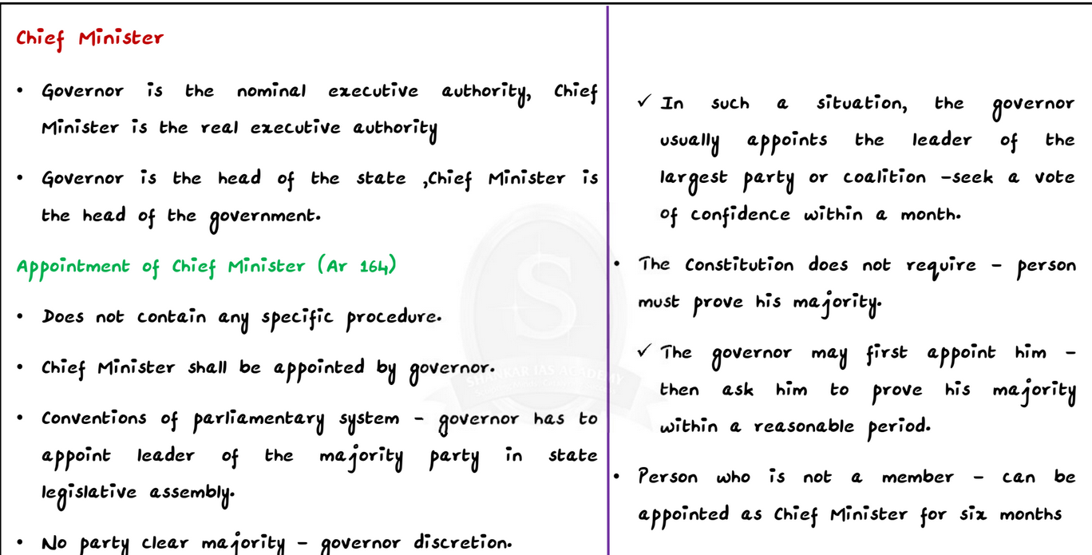**New CM Uttarakhand**

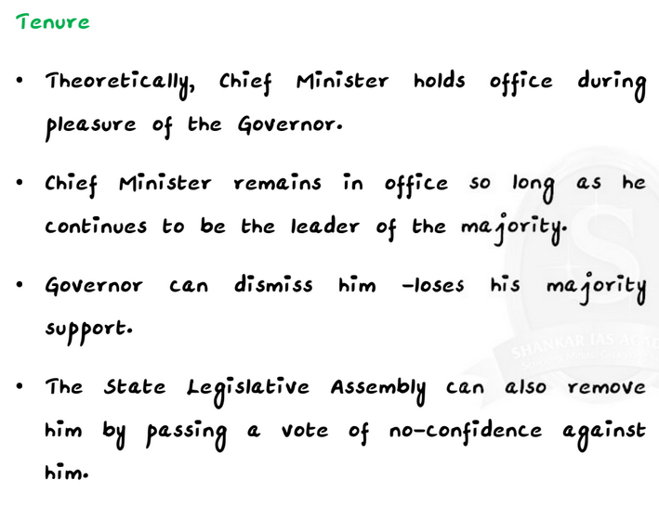

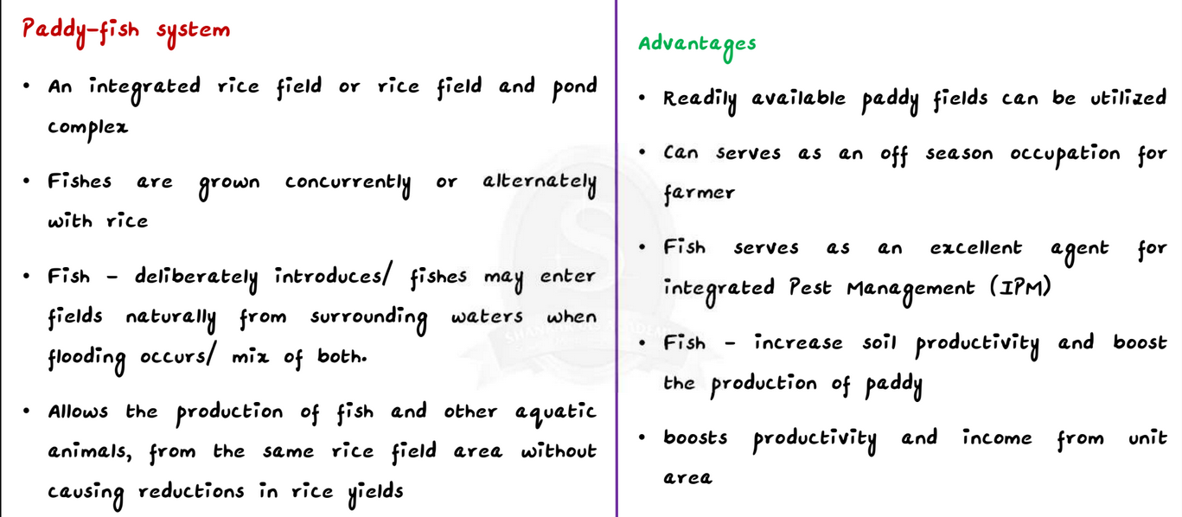**Paddy Fish and Rabha Tribes**

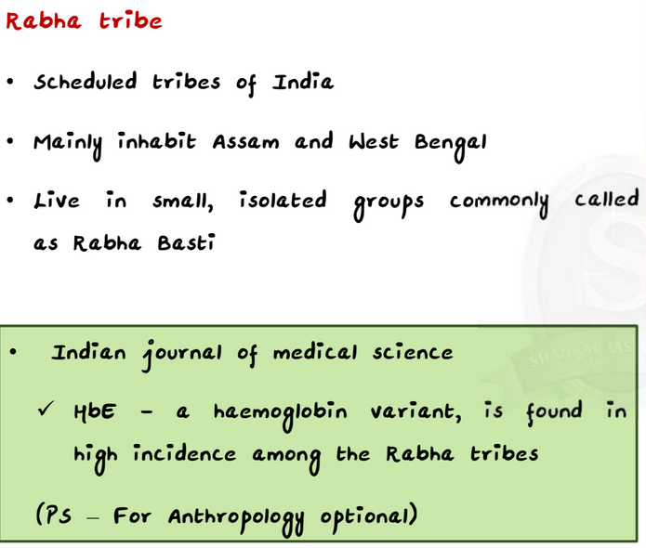

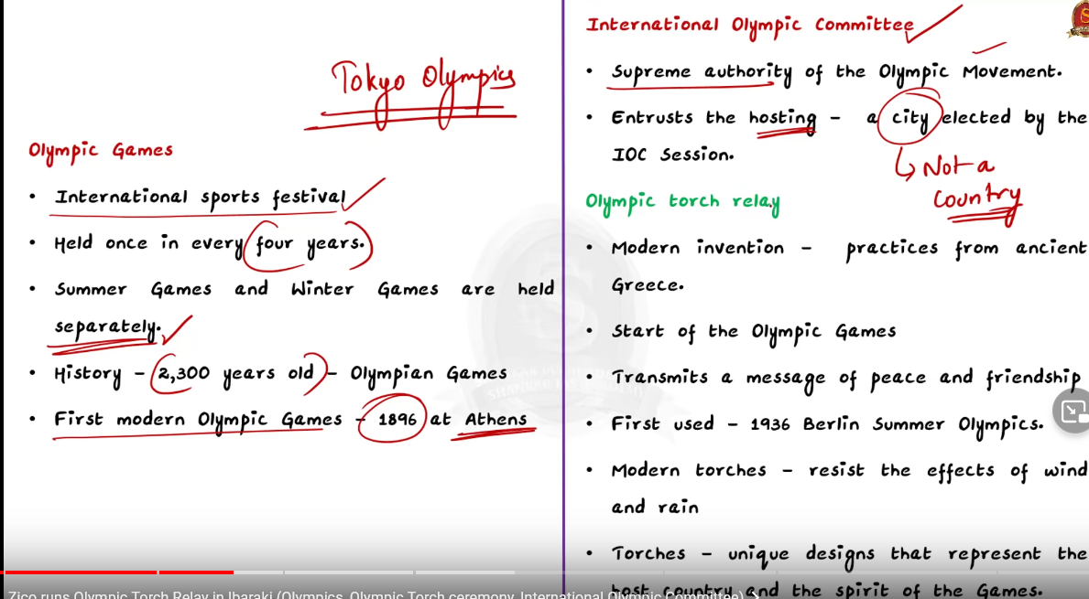**OLYMPICS**

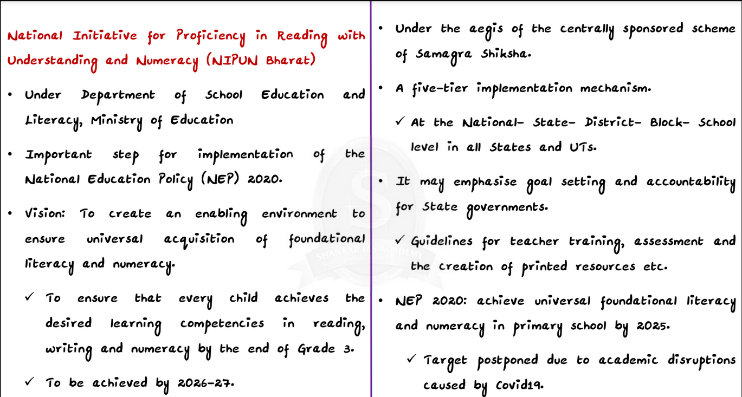**NIPUN BHARAT**

Ministry of Education is launching **National Initiative for Proficiency in Reading with Understanding and Numeracy (NIPUN Bharat)** today i.e 5th July, 2021 as a part of the National Mission on Foundational Literacy and Numeracy.

The mission aims to ensure that every Class 3 child has foundational literacy and numeracy within five years.

**National Education Policy 2020** had included a 2025 deadline to achieve the goal, the Centre has pushed back the target date to 2026-27, given that COVID 19 has already disrupted two academic years.

The launch of NIPUN Bharat marks an important step undertaken by the Department of School Education and Literacy, among a series of measures taken for implementation of the National Education Policy 2020.

• The vision of NIPUN Bharat Mission is to create an enabling environment to ensure universal  acquisition of foundational literacy and numeracy, so that **every child achieves the desired  learning competencies in reading, writing and numeracy by the end of Grade 3**, by 2026- 27.

• NIPUN Bharat will be implemented by the Department of School Education and Literacy and a five-tier implementation mechanism will be set up at the National- State- District-Block School level in all States and UTs, under the aegis of the centrally sponsored scheme of  Samagra Shiksha.

• NIPUN Bharat is likely to emphasise goal setting and accountability for State governments, and provide guidelines for teacher training, assessment and the creation of printed resources, according to people who helped develop the mission.

• It will be funded through Samagra Shiksha itself. There is no additional allocation being made.

• “Samagra Shiksha is an umbrella scheme, and this year it has been revised. According to that revision, a provision has been kept for FLN (foundational literacy and numeracy).

• This mission specifies stagewise learning goals to ensure that students are acquiring the necessary building blocks.